DengueX: An AI-Powered Dengue Surveillance, Analytics, and Public Health Awareness System


By:
M.Wassam Baig
35456
Adil Mehmood Awan
38269

Supervised by:
Mr. Ihtisham Ullah

Faculty of Computing
Riphah International University, Islamabad
Fall 2025

A Dissertation Submitted To

Faculty of Computing,
Riphah International University, Islamabad
As a Partial Fulfilment of the Requirement for the Award of the Degree of
Bachelors of Science in Computer Science

Faculty of Computing
Riphah International University, Islamabad
Date: 22/12/2025

Final Approval
This is to certify that we have read the report submitted by Muhammad Wassam Baig (35456), Adil Mehmood Awan (38269), for the partial fulfilment of the requirements for the degree of Bachelor of Science in Computer Science (BSCS). It is our judgment that this report is of sufficient standard to warrant its acceptance by Riphah International University, Islamabad for the degree of Bachelor of Science in Computer Science (BSCS)

Committee:

1 | Mr. Ihtisham Ullah  (Supervisor)
2 | Dr. Musharraf Ahmed  (Head of Department)
Declaration

We hereby declare that this document DengueX neither as a whole nor as a part has been copied out from any source. It is further declared that we have done this project with the accompanied report entirely on the basis of our personal efforts, under the proficient guidance of our teachers, especially our supervisor Mr. Ihtisham Ullah. If any part of the system is proved to be copied out from any source or found to be reproduction of any project from anywhere else, we shall stand by the consequences.
___________________________
Muhammad Wassam Baig
35456

___________________________
Adil Mehmood Awan
38269

Dedication

Our project is dedicated to our beloved parents, seniors, friends, and especially our supervisor Ihtisham Ullah who has been our continual source of inspiration and whose support has helped this project succeed. Their sacrifices and strong belief in us gave us the strength to face difficulties and keep working hard. We are also thankful to our seniors and friends, who helped us a lot with their advice and support. Most of all, we want to thank our supervisor, for his constant encouragement, helpful guidance and patience, which were very important for finishing his project successfully. Without the love and support from all these amazing people, this project would not have been possible. We are very grateful to each one of them for being a part of our journey.

Acknowledgement

First of all, we are obliged to Allah Almighty the Merciful, the Beneficent and the source of all Knowledge, for granting us the courage and knowledge to complete this Project. We are grateful to our respected supervisor Ihtisham Ullah, we are highly obliged for his consideration, and the suggestions he gave us to make our project a masterpiece. Also, a special thanks to the rest of the faculty members for their unconditional support. We are thankful to our parents for the love and encouragement they provided us with throughout the project.
___________________________
Muhammad Wassam Baig
35456

___________________________
Adil Mehmood Awan
38269

Abstract
Dengue fever, a mosquito-borne viral illness that spreads quickly, is a major public health concern, especially in developing countries like Pakistan. More frequent outbreaks mean we need smart, tech-cantered answers that can raise public awareness. These solutions should allow early prevention and help with good disease control. Current info systems for dengue are often disjointed, reactive, and don't have real-time communication with the public.
DengueX, a digital health system powered by AI, aims to assist with awareness, tracking, and prevention. It includes a smart health assistant for advice on dengue, a dashboard to see trends, an AI module to spot mosquitoes that carry dengue, and a way for people to report issues to boost community involvement. The goal is to connect citizens, health groups, and tech by giving correct info, helpful insights, and good reporting tools.
During this project's first part, we look at the problem, review published work, define system needs, and create a high-level system design. This work sets up the base and structure to create a smart dengue control platform. The second part will focus on putting the system in place, adding advanced AI, refining models, handling real-time data, and checking the system based on how well it works and how easy it is to use. By using AI, data analysis, and web tech, DengueX seeks to lower dengue-related dangers, raise public awareness, and back data-based decision-making for dengue control.

Table Of Content
Chapter 1: Introduction 9
1.1 Introduction 10
1.2 Project Motivation 10
1.3 Problem Statement 11
1.4 Proposed Solution 11
1.5 Objectives of the Project 12
1.6 Scope of the Project 12
1.7 Significance of the Project 12
Chapter 2: 14
Literature Review 14
And Gap Analysis 14
2.2 Dengue Monitoring Systems 15
2.3 AI Health Assistance Platforms 15
2.4 Mosquito Detection Technologies 15
2.5 Citizen-Based Health Reporting 16
2.6 Comparative Study of Existing Systems 16
2.6 Comparative Study of Existing Systems 17
Chapter 3: 19
System Analysis 19
And 19
Requirements 19
3.1 Introduction 20
3.2 Problem Analysis 20
3.3 Proposed System Overview 20
3.4 Stakeholder Analysis 21
3.4.1 Citizens 21
3.4.2 Administrators 22
3.4.3 Health Authorities 22
3.5 System Functional Requirements 23
3.6.1 Performance 23
3.6.2 Security 23
3.6.3 Usability 24
3.6.4 Scalability 24
3.6.5 Reliability 24
3.7 Use Case Analysis 25
3. 7. 1 Use Case: Dengue Question Inquiry 25
4. 7. 2 Use Case: Reporting Potential Breeding Site 25
5. 7. 3 Use Case: Administrator Review of Reported Site 25
3.8 Feasibility Analysis 26
3. 8. 1 Technical Aspects 26
3. 8. 2 Economic Aspects 26
8. 3 Operational Aspects 26
3.9 Chapter Summary 26
Chapter 4 System Design 27
4.1 Introduction 28
4.2 Overall System Architecture 28
4.3 Architectural Diagram Description 29
4.4 Module-Based System Plan 29
4.4.1 User Authentication Module 29
4.4.2 AI Dengue Chatbot Module 30
4.4.3 Dengue Data Dashboard Module 31
4.4.4 Mosquito Detection Module 32
4.4.5 Citizen Reporting Module 33
4.4.6 Administrative Control Module 34
4.5 Data Flow Design 35
4.6 Database Design Overview 35

Chapter 1:
Introduction

Introduction
Dengue fever, a viral sickness carried by mosquitoes, comes from the dengue virus (DENV) in the Flaviviridae family. It mainly spreads through bites from infected female Aedes aegypti mosquitoes, which live in tropical and subtropical areas [1]. Dengue is now a big problem for public health across the globe, with about 390 million infections each year. Around 96 million of these infections show symptoms [2].
Fast city growth, climate changes, population increases, and poor waste handling have all greatly increased places where mosquitoes can breed. Because of this, dengue outbreaks are happening more often, are more serious, and are spreading to more areas. The World Health Organization (WHO) lists dengue as one of the top ten dangers to world health because it is becoming a bigger problem and there are not many specific antiviral treatments available [3].
Pakistan, for example, has had many dengue outbreaks in the last 20 years. Big cities like Lahore, Karachi, Islamabad, and Rawalpindi report thousands of dengue cases each year, which often puts too much pressure on hospitals [4]. Seasonal monsoon rains worsen the situation by creating pools of standing water that are perfect for mosquitoes to breed in. Even with government-run awareness programs, stopping dengue and finding it early are still difficult.

Project Motivation
This project was started because current dengue prevention and awareness methods have problems. The usual ways depend on people reporting, slow stats, and websites that don't do much. These systems don't get people involved or give quick, personal help when there are outbreaks. Another big worry is that wrong info spreads about dengue symptoms, treatments, and ways to prevent it. Many people use social media or sources that aren't checked, which can cause late diagnosis or wrong medicine use [5]. Also, Pakistan's public health systems don't use AI and data analysis much. With better AI, machine learning, and web tech, we can create a smart system. It will give correct medical advice, show how diseases spread, and let people join in. DengueX is designed to put these new technologies into one place for dengue awareness, prevention, and control.

Problem Statement
Despite the availability of healthcare services and awareness campaigns, dengue continues to pose a serious threat due to several unresolved issues:
- Lack of an intelligent, interactive system that provides reliable dengue-related guidance to the public.
- Absence of real-time visualization of dengue cases and trends for informed decision-making.
- Inefficient reporting mechanisms for mosquito breeding sites and stagnant water locations.
- Limited use of AI-based tools for early detection of dengue-carrying mosquitoes.
- Poor integration between citizens, healthcare authorities, and data-driven technologies.
These challenges highlight the need for a comprehensive digital solution that leverages artificial intelligence and modern web technologies to address dengue-related concerns effectively.

Proposed Solution
To tackle these problems, this project introduces DengueX, an AI system for dengue information and awareness. DengueX is a flexible digital platform that puts several smart parts into one place.
This system includes:
- A health assistant using AI that gives correct answers to questions about dengue.
- A dashboard that shows dengue trends, how serious cases are, and where they appear.
- An AI tool that spots types of mosquitoes that carry dengue.
- A way for people to report mosquito breeding areas and see what's happening with their reports.
DengueX seeks to make people more aware, help with early prevention, and give officials info to make decisions.

1.5 Objectives of the Project
The objectives of the project are categorized into primary and secondary objectives.
Primary Objectives
- To design an AI-powered system that provides accurate dengue-related information.
- To improve dengue awareness and prevention through intelligent digital tools.
- To support public health authorities with data visualization and reporting mechanisms.
Secondary Objectives
- To integrate AI techniques for mosquito species detection.
- To enable citizen participation through an interactive reporting system.
- To design a scalable system that can be extended with additional features in future phases.

1.6 Scope of the Project
The scope of DengueX includes:
- Development of an AI health assistant for dengue guidance.
- Visualization of dengue statistics and trends.
- Detection of dengue-carrying mosquito species using image analysis.
- Citizen-based reporting and administrative management features.
The project does not include direct medical diagnosis, prescription of medication, or real-time hospital integration. DengueX is designed as a support and awareness system, not a replacement for professional medical consultation.

1.7 Significance of the Project
DengueX holds significance for multiple stakeholders:
- Citizens gain access to reliable, instant dengue-related information.
- Healthcare authorities receive structured reports and visual insights.
- Government bodies can utilize trend analysis for policy-making.
- Researchers and developers benefit from a scalable AI-based health platform.
By combining AI, data visualization, and citizen engagement, DengueX contributes toward smarter public health management.

Chapter 2:

Literature Review

And Gap Analysis

2.1 Introduction
This section gives a review of current studies, systems, and tech linked to the project. For dengue prevention, many digital tools, monitoring systems, and health sites have come out all over the globe. Still, most of these tools only do things like report cases or share basic info. They don't use AI or get people involved.
This part looks at current systems for dengue, AI health apps, and tech for finding mosquitoes. It also points out what these systems can't do and spots areas where more study is needed, which is why DengueX is being created.

2.2 Dengue Monitoring Systems
A number of international groups run systems to watch and track dengue fever. The World Health Organization (WHO) has a global system that collects info from member countries and puts out reports on a regular basis [1]. These systems work well for studying the spread of the disease, but people can't use them directly.
In Pakistan, the National Institute of Health (NIH) and local health departments put out info on dengue cases on official websites [2]. These sites give stats, but they don't have features that allow interaction, show data in real time, or give smart advice to the public. The info is often late, which makes it less helpful when there are outbreaks.

2.3 AI Health Assistance Platforms
AI resources like Ada Health, Babylon Health, and WebMD Symptom Checker give automated info for health questions [3]. These tools show AI's support in healthcare; yet, they tackle many medical issues instead of mainly focusing on dengue.
Also, many AI health systems need the internet to work. This limits who can use them in areas where the internet is not stable, a common issue in parts of Pakistan.

2.4 Mosquito Detection Technologies
Current work has looked into using machine learning and computer vision to ID mosquito types. Studies employing CNNs have shown good correctness in spotting Aedes aegypti, the main dengue-carrying mosquito [4]. Even with these good results, these setups are mostly used in research. They are seldom found in public apps and often need certain hardware and big data collections, which limits their use in actual public health setups.

2.5 Citizen-Based Health Reporting
Citizen involvement is key to today's public health systems. Platforms like HealthMap and Flu Near You let people report sickness symptoms and events, which aids in the early finding of outbreaks [5]. Still, these setups don't have ways to check reports and don't use AI to confirm what users send in.
In Pakistan, people usually deal with dengue complaints through old-style helplines or paper reports. These ways are slow, hard to keep tabs on, and don't give much feedback to people, cutting down on public confidence and involvement.

2.6 Comparative Study of Existing Systems
To gain a clearer view of what current dengue systems can and can't do, we did a study comparing platforms from both around the world and here at home. Our comparison looked at what each platform can do, how easy it is for people to use, how smart it is, and where it falls short in practice.
Our study shows that while current solutions do keep an eye on dengue, they don't offer the complete, smart, and user-friendly approach that's needed. Most platforms tend to focus on either reporting data or giving general health advice. None of them put together AI guidance specific to dengue, real-time maps, mosquito detection, and citizen reporting all in one place. This comparison really drives home the need for a single, go-to platform like DengueX.

Table 2.1 presents a comparison of selected existing systems, their primary functionalities, and key limitations.
No. | System | Organization | Features | Limitations
1 | Dengue GP App | Punjab Information Technology Board (PITB) | Doctor-based dengue case reporting, centralized dengue surveillance | Limited to Punjab, no AI-based assistance, not accessible to general public
2 | Punjab Anti Dengue System | Punjab IT Board | Citizen and field staff reporting, geo-tagged larval site monitoring | Manual data entry, no intelligent analytics
3 | Smart Dengue Monitoring System | PITB & Punjab Health Department | GIS-based dashboards, dengue trend monitoring | Restricted access, no citizen interaction
4 | NIH Dengue Surveillance Portal | National Institute of Health (NIH), Pakistan | Dengue guidelines, outbreak statistics, reports | Static data, no real-time user engagement
5 | WHO Dengue Dashboard | World Health Organization (WHO) | Country-level dengue statistics, global maps | Informational only, no reporting or AI support

From the comparison, it is evident that although these systems contribute individually to dengue awareness and monitoring, none of them provide a comprehensive, intelligent, and user-interactive solution suitable for large-scale public use, particularly in developing countries.

2.6 Comparative Study of Existing Systems
We did a gap analysis to find the weak points in current systems and show how DengueX adds value. This analysis links each weakness to a feature in our system.
The goal of this gap analysis is to explain why we designed DengueX the way we did and how it betters current solutions by using AI, real-time data analysis, and input from the public.

Table 2.2 summarizes the identified gaps in existing systems and explains how DengueX addresses them.
Feature Area | Existing System(s) | Website / Source | Identified Gap | How DengueX Addresses the Gap
AI-Based Health Guidance | Dengue GP App, NIH Portal | pitb.gov.pk, nih.org.pk | No intelligent chatbot for user queries | AI-powered dengue chatbot providing instant medical guidance
Citizen Interaction | Punjab Anti Dengue System | pitb.gov.pk | Limited user engagement, manual reporting | User-friendly reporting with AI support and status tracking
Mosquito Species Detection | Manual field inspections | pitb.gov.pk | No automated mosquito identification | AI-based mosquito image analysis to detect dengue vectors
Real-Time Public Analytics | Smart Dengue Monitoring System | pitb.gov.pk |  | Public-facing executive dashboard with visual analytics
  Dashboards restricted to officials
Integrated Dengue Platform | WHO Dengue Dashboard | who.int | Fragmented systems, no unified platform | All-in-one dengue management system combining AI, analytics, and reporting

The gap analysis confirms that DengueX effectively bridges critical gaps present in existing systems by offering an AI-driven, interactive, and scalable platform. This strengthens its relevance as a modern digital health solution tailored specifically for dengue prevention and management.

Chapter 3:

System Analysis

And

Requirements

3.1 Introduction
System analysis is key in software creation because it lays out the system's functions and behaviour. This section studies the DengueX system by looking at its functions, technical aspects, and user needs. It names the people involved, reviews how the system works, and spells out what the system must do. This section aims to make sure everyone understands the system well before moving on to design and building it.

3.2 Problem Analysis
Dengue fever outbreaks continue to pose a major public health challenge for Pakistan. This is largely due to several factors: delays in educating people about the disease, a lack of a central source for dengue-related data, and problems with the way cases are reported.
Current systems are limited by these issues:
- Dengue-related details are spread across a number of places.
- People can't quickly get reliable medical advice.
- Reporting locations where mosquitos breed is slow and tracking is poor.
- Visual displays of dengue stats are limited or not interactive.
- Officials get field reports late or that are not complete.
These issues show that there's a real need for a digital system that is not only centralized and smart, but also puts the focus on the needs of the people it serves. DengueX is designed to be that kind of system.

3.3 Proposed System Overview
DengueX represents a digital tool that makes use of computer intelligence to aid in dengue education, preventative actions, surveillance, and the reporting of cases. The layout of the system involves several distinct but interlinked parts within one location:
- AI Health Assistant (Chatbot): This feature acts like a virtual helper, answering questions and giving guidance on dengue-related matters. It is intended to provide information and support to individuals.
- Dengue Data Dashboard: The dashboard shows organized data related to dengue fever. It is a tool for seeing trends, clusters and key information that is relevant to public health. Mosquito Detection Module: This part focuses on spotting mosquito populations, which carry the dengue virus. It could include techniques to find breeding grounds or track mosquito movement in certain zones.
- Citizen Reporting System: This element enables people to contribute to the wider effort to manage dengue. People can report possible dengue cases, mosquito sightings or other related info.
- Administrative Control Panel: This section lets administrators manage and oversee the entire system. It offers tools for data control, user management, and system settings.
Each of these parts serves a particular purpose while also adding to an integrated setup for dengue control. The point is to have each section run on its own while working with the others for a more complete strategy.

3.4 Stakeholder Analysis
The DengueX system is designed to serve a diverse group of stakeholders, each with distinct roles and specific expectations regarding the system's capabilities and outputs. Understanding these different perspectives is important for the successful implementation and maintenance of the DengueX system.

3.4.1 Citizens
Citizens form a primary group of users for the DengueX system. Their interactions with the system are designed to provide them with relevant information about dengue fever and engage them in efforts to control the disease. Specifically, citizens can:
- Access information about dengue fever through an AI-powered chatbot. This feature allows citizens to ask questions about the disease, its symptoms, prevention methods, and current outbreak status in their area.
- View statistics and trends related to dengue fever. This includes access to data on the number of cases reported, geographic distribution of infections, and changes in disease patterns over time. This information helps citizens understand the risk level in their communities and take appropriate precautions.
- Report potential mosquito breeding sites and larvae. By reporting standing water or other conditions conducive to mosquito breeding, citizens can contribute to the elimination of these sites and reduce the mosquito population.
- Upload images of mosquitoes for analysis. This feature allows citizens to submit photos of mosquitoes they encounter, which can then be analysed to identify the species and assess the risk of disease transmission.

3.4.2 Administrators
Administrators are personnel responsible for the day-to-day operation and maintenance of the DengueX system. Their roles involve managing data, verifying information, and ensuring that the system functions properly. Their responsibilities include:

- Managing data related to dengue fever cases. This involves entering, updating, and maintaining records of confirmed and suspected cases, as well as tracking patient information and treatment outcomes.
- Verifying reports submitted by citizens. Before this information is added to the system, administrators will verify reports of breeding sites and mosquito sightings to ensure accuracy and prevent the spread of misinformation.
- Publishing health advisories and public announcements related to dengue fever. These may include warnings about outbreaks, recommendations for preventive measures, and information about available resources.
- Monitoring system activity to ensure optimal performance and security. This includes tracking user access, identifying potential security threats, and addressing technical issues.

3.4.3 Health Authorities
Health authorities represent the government agencies and organizations responsible for public health and disease control. These stakeholders use the DengueX system to inform decision-making and implement strategies to combat dengue fever. Their functions include:
- Using data analytics to inform public health decision-making. Examining patterns and trends in dengue fever cases allows health authorities to make informed decisions about resource allocation, intervention strategies, and public health campaigns.
- Identifying geographic areas with a high risk of dengue fever transmission. By analysing data on case incidence, mosquito populations, and environmental factors, health authorities can target interventions to these high-risk areas.
- Tracking the patterns of dengue fever outbreaks to understand how the disease is spreading and identify effective control measures. This involves monitoring the geographic distribution of cases, analysing transmission dynamics, and assessing the impact of interventions over time.

3.5 System Functional Requirements
Non-functional requirements are crucial in defining the quality attributes of a system, influencing its overall user experience and operational. They specify *how well* the system carries out its functional tasks, covering aspects like speed, security, ease of use, ability to grow, and dependability.

3.6.1 Performance
- Response Time: The system is designed to provide quick responses to user queries. It should generally respond within a few seconds, ensuring users receive information without noticeable delays.
- AI Response Retrieval: For AI-driven interactions, the responses from the system should be retrieved quickly. This means employing efficient algorithms and data structures to minimize latency and deliver timely information.

3.6.2 Security
- User Authentication: To protect user accounts and data, the system will employ strong authentication methods. These methods are designed to verify user identities before granting system access, guarding against unauthorized entry.
- Data Protection: It is critical to protect sensitive data from unauthorized access. Security measures will be implemented to encrypt data, control access permissions, and monitor for potential security breaches, ensuring data confidentiality and integrity.

3.6.3 Usability
- Interface Design: The system will have a user interface designed for simplicity and intuitiveness. The goal is to create an easy-to-understand design that allows users to efficiently interact without extensive training or specialized expertise.
- Accessibility: To broaden its accessibility, the system is built to be easily used by people who may not have deep technical skills. The design aims to provide a straightforward and user-friendly experience, enabling a wider audience to interact effectively with the system.

3.6.4 Scalability
- Support for Feature Expansion: Anticipating future needs, the system’s architecture is designed to accommodate the addition of new features and functionalities with minimal disruption. This flexibility ensures the system can from new requirements or evolving user demands.
- Handling Increased Load: The architecture is designed to efficiently manage increases in the number of users and the volume of data. Scalable infrastructure and design patterns are adopted to maintain optimal performance and responsiveness as demand grows, ensuring the system remains stable and reliable under heavy load.

3.6.5 Reliability
- System Stability: The system is engineered to maintain stable operation, even during periods of high user activity or peak loads. Redundancy measures, load distribution techniques, and rigorous testing protocols are put to use to ensure the system remains up and running, delivering services without interruption.
- Consistency and Accuracy: AI-driven responses should be consistently reliable and accurate. This requires continuous updates to maintain quality and relevance.

3.7 Use Case Analysis
In system design, use cases represent the scenarios where users interact with the system to achieve aims. Below are examples of use cases in a dengue prevention system, specifying the actors involved, the steps taken, and the expected results:

3. 7. 1 Use Case: Dengue Question Inquiry
- Actor: Citizen
- Description: A citizen poses a question pertaining to dengue fever through the system's interface. This could include inquiries about symptoms, prevention advice, or treatment information. The user enters their question in a text box. The system then processes the question to identify relevant information.
- Outcome: The AI chatbot, trained on verified dengue-related data, gives a response. This response should give accurate, up-to-date, and easily understandable information to the user. The chatbot should cite the sources of its information so the user can verify the information. The system should save the question and the response to monitor chatbot performance and make improvements.

4. 7. 2 Use Case: Reporting Potential Breeding Site
- Actor: Citizen
- Description: A citizen notices a possible breeding site for dengue-carrying mosquitoes and wants to report it to the proper authorities. The user takes a picture of the site and uses the system to upload the image, together with its location to the system. The position can be captured automatically through GPS or entered manually. The user might also add details. The system collects this data and prepares it for submission.
- Outcome: The system creates a report of the possible breeding site and submits it to the system's administrators for review. The citizen receives confirmation that their report has been successfully submitted. The report includes all of the information collected, including the image, location, and description, and is placed in a queue for administrator assessment.

5. 7. 3 Use Case: Administrator Review of Reported Site
- Actor: Administrator
- Description: An administrator accesses the system to review reports submitted by citizens about possible dengue breeding sites. The administrator examines the evidence included in the report, such as the image, location, and any descriptive notes, to see whether the report is valid. The administrator may use external sources, such as maps or weather data, to help with the review.
- Outcome: After reviewing the report, the administrator can update the status of the report to accepted or rejected. If the report is accepted, the system sends a notification to the reporting citizen, informing them that action will be taken. If the report is rejected, the administrator gives a reason for the rejection, and the citizen is notified. The administrator's choice and justification are recorded in the system for auditing and tracking purposes.

3.8 Feasibility Analysis

3. 8. 1 Technical Aspects
The system is technically achievable because it relies on common tech like Python, Django, and AI models.

3. 8. 2 Economic Aspects
The system is economically viable since it uses open-source tools, which keeps development costs low.
8. 3 Operational Aspects
The system is user-friendly for both citizens and administrators.

3.9 Chapter Summary
This chapter analysed the DengueX system in terms of problems, users, requirements, and feasibility. The analysis confirms that DengueX is a viable and necessary solution to address dengue awareness and management challenges. The next chapter focuses on system design and architectural modelling.

Chapter 4
System Design

4.1 Introduction
System design translates the requirements identified in the analysis phase into a structured and implementable solution. This chapter presents the architectural design, module-level design, data flow, and interface design of the DengueX system. The design focuses on modularity, scalability, and maintainability to ensure smooth future enhancements.

4.2 Overall System Architecture
DengueX is structured with a modular, layered design. This separates how users interact with the system from the core application functions, the artificial intelligence, and how the data is managed. Dividing the system this way means the different parts are not tightly joined, which makes it easier to update or fix specific components without disrupting the whole system.
The system is arranged into four main sections:
1. Presentation Layer (Web Interface): This is what users see and interact with, such as the website or application interface. It allows users to input data and see results.
2. Application Layer (Backend Logic): This part handles the main functions of the DengueX system. It takes user requests from the presentation layer and processes them. This involves calculations, data retrieval, and other operations needed to run the application.
3. AI Processing Layer: This is where the artificial intelligence algorithms are applied. It processes data, identifies patterns, and makes predictions related to dengue fever. This layer enhances the system's ability to provide meaningful insights and support decision-making.
4. Data Management Layer: This component is in charge of storing, retrieving, and managing all the data DengueX uses. It keeps the data secure, organized, and accessible to other layers as needed.
Each of these layers is designed to communicate with the others through defined interfaces. This ensures that the system is dependable and can handle increasing amounts of data or users without failing. The interfaces act as contracts, specifying how each layer can request services or data from another, making the system easier to scale and maintain. For example, if the AI processing layer needs to be upgraded with newer algorithms, it can be done without affecting the presentation or application layers, as long as the interface remains consistent. This modular design promotes flexibility and longevity of the DengueX system.

4.3 Architectural Diagram Description
To give more clarity, let’s examine the system's design.
- People visiting the website can use all available features through the web interface. In essence, the web interface is the primary point of interaction for the user.
- Requests made by users are then sent to the backend application. This application layer is the central hub that handles all requests.
- Within the backend, there are specialized modules with artificial intelligence. These modules are very useful for processing complex tasks, such as understanding chatbot queries and handling image uploads. The chatbot module can interpret what a user types and offer proper answers. The image processing module allows users to upload images, which the system can then analyse.
- The backend interacts with the database to retrieve or update information, depending on the user's request. The database stores all the necessary data for the system to operate correctly.
- The results of these processes are sent back to the user interface. This happens in real time, providing the user with instant feedback. This step is important for keeping the user engaged and informed.
This design makes sure the system runs smoothly and provides a good user experience, while also keeping the data safe and consistent. This streamlined flow is vital for both user satisfaction and the general stability of the system.

4.4 Module-Based System Plan
The DengueX system follows a modular design, with individual components handling specific functions.

4.4.1 User Authentication Module
This module manages user access and profiles securely.
Main Functions:
  - User registration and login processes.
  - Password recovery using security questions for verification.
  - Access control based on user roles (Citizen or Administrator).
This module ensures that only authenticated users can reach sensitive parts of the system. It protects user data and system integrity by controlling who has permission to do what. The role-based access system grants regular users limited access, while administrators have full control over the system.
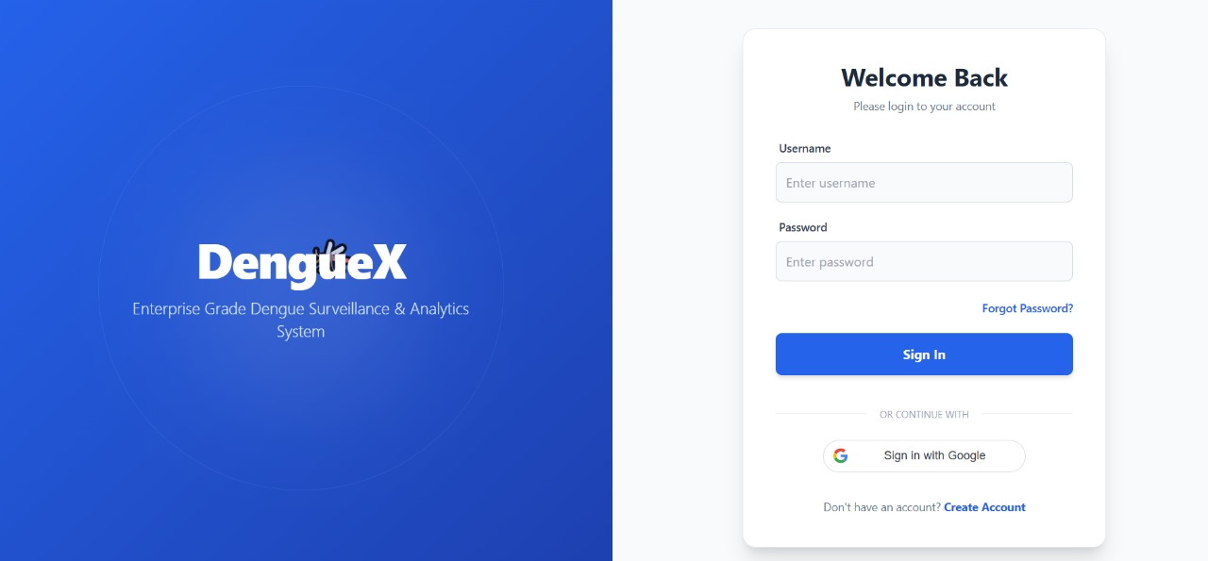
Figure 4.2: User authentication interface

4.4.2 AI Dengue Chatbot Module
The AI Health Assistant is a central part of DengueX, created to assist users with dengue-related questions.
Design Characteristics:
  - The chatbot is trained using datasets containing information specific to dengue fever.
  - It processes user inquiries almost immediately, giving quick answers.
  - It is programmed to refuse questions outside the topic of dengue fever.
  - The responses it gives are checked by medical professionals for accuracy.
The chatbot works without depending on external application programming interfaces (APIs), which makes it dependable even when internet access is limited. It gives users instant access to details and guidance about dengue fever, lowering their need to search for answers elsewhere. The chatbot helps people who do not understand the sickness, and is very trustworthy because it is trained by medical professionals.
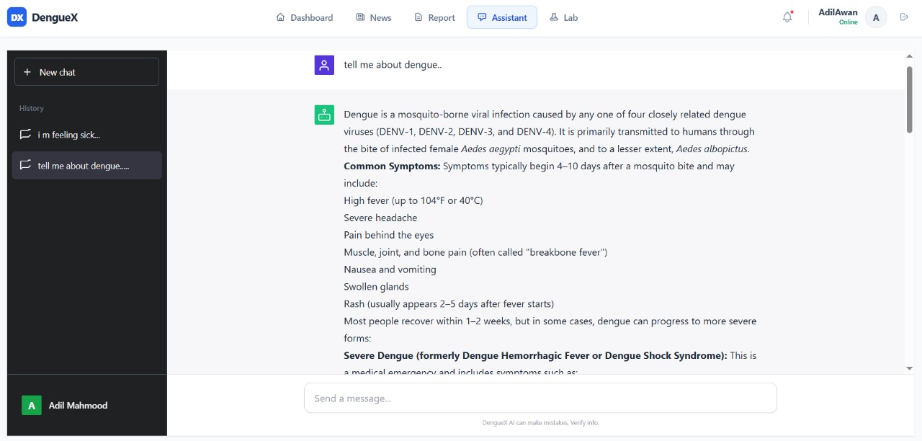
Figure 4.3: AI-based dengue chatbot providing user guidance

4.4.3 Dengue Data Dashboard Module
This module focuses on displaying dengue-related data for simple understanding.
Main Features:
  - Shows the number of dengue cases, recoveries, and deaths.
  - Breaks down statistics by city.
  - Makes charts and graphs to show patterns.
  - Allows analysis of data over time.
This dashboard allows regular citizens and authorities to see and understand dengue outbreak patterns. By showing key measures and trends, the dashboard aids decision-making and resource allocation intended to combat the spread of the disease. Maps are included to show outbreaks in certain areas.
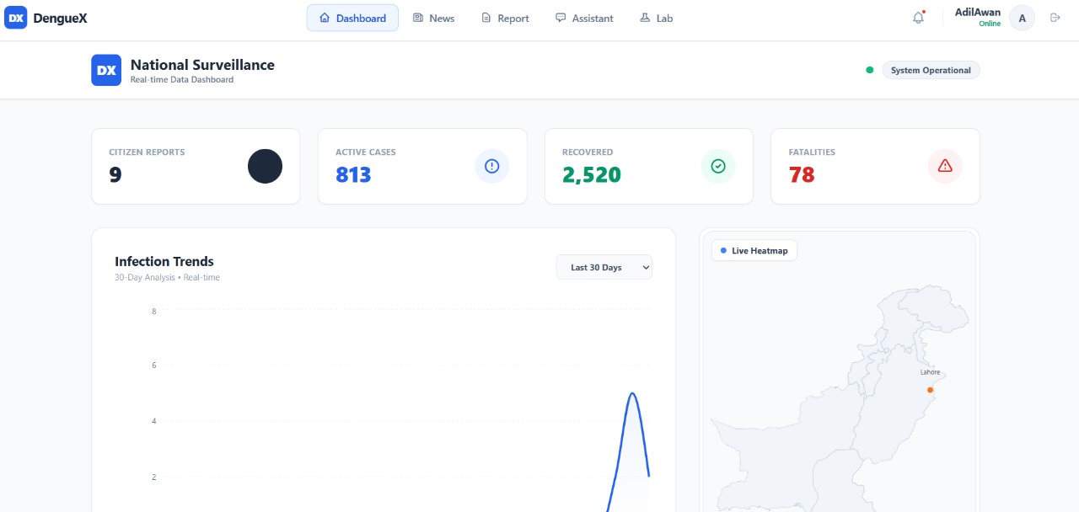
Figure 4.4: Dengue data dashboard with statistical visualization

4.4.4 Mosquito Detection Module
This module uses image analysis to spot mosquitoes that can transmit dengue.
Design Details:
- Allows users to send in pictures of mosquitoes.
- Uses trained AI models to tell species apart.
- Decides if a mosquito is likely to carry dengue.
- Returns a risk assessment result.

This module promotes preventive steps against dengue at the community level. By allowing users to upload images of mosquitoes and receive quick assessments, people can immediately decide and take action to lower their dangers. Real-time tracking of mosquito populations can be done to control mosquito populations.
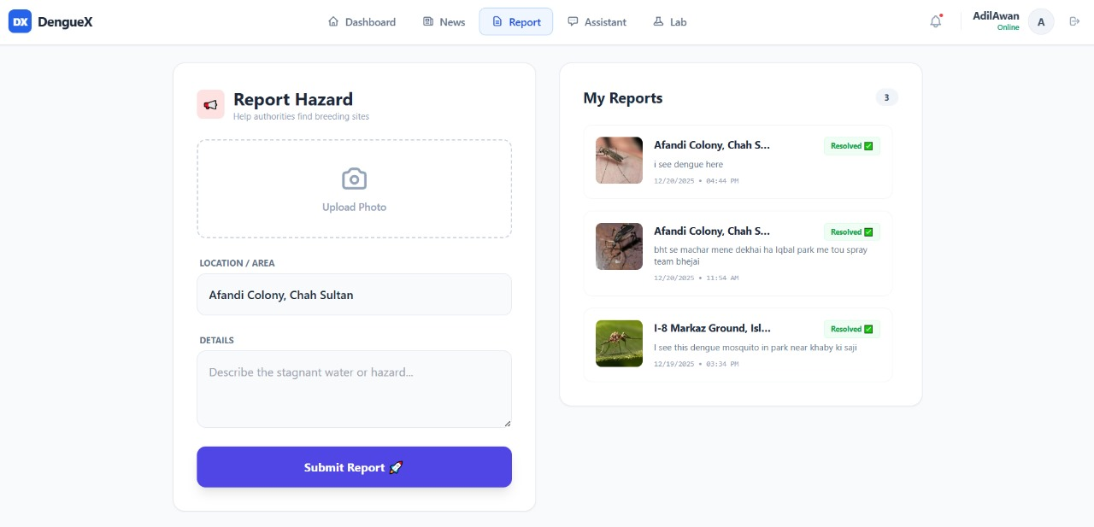
Figure 4.5: AI-based mosquito species detection module

4.4.5 Citizen Reporting Module
This module allows users to report dengue occurrences in their areas actively to help disease prevention efforts.
Design Parts:
- A standard report submission form is easy and understandable.
- Options to upload pictures and detailed descriptions.
- An automatic system to track the status of submitted reports.
- A system to send notifications to keep users up-to-date on their reports.
Reports from citizens are sent to administrators so they can check the information. This creates community involvement in keeping watch over disease outbreaks, allowing administrators to give attention to problem areas and respond faster to manage dengue risks. The quick reporting allows for disease management to be effective.
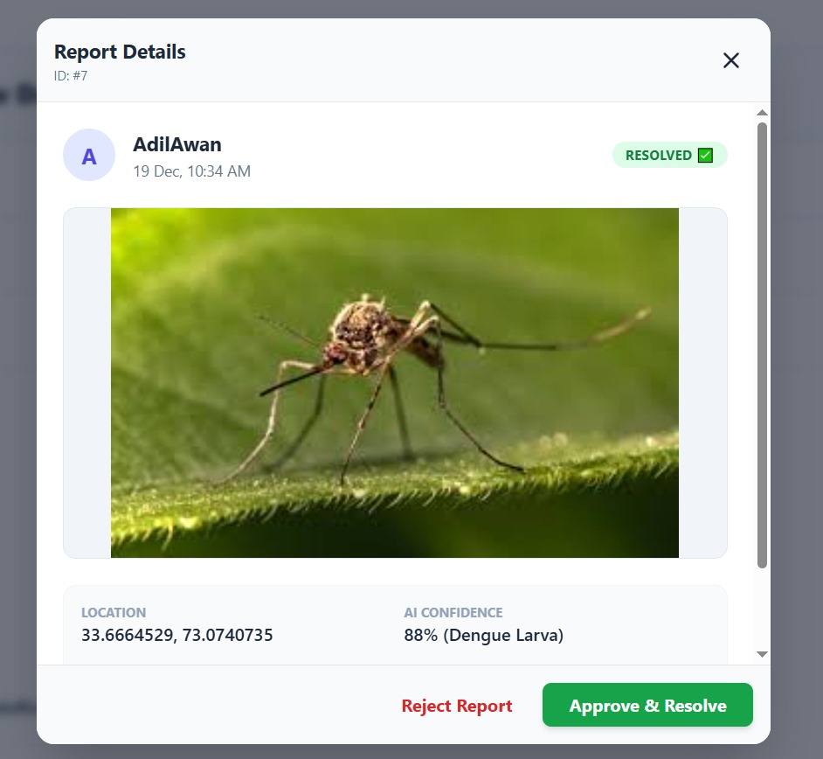
Figure 4.6 shows the detailed report verification interface, where administrators can view submitted evidence, AI confidence scores, and take final actions by approving or rejecting reported dengue breeding sites.

4.4.6 Administrative Control Module
The admin panel is for supervising and managing the system.
Main Functions:
  - Checking and confirming reports from citizens.
  - Handling dengue statistics to make sure the system is accurate.
  - Taking actions such as blocking or unblocking users.
  - Posting public health notifications to inform the community.

This module guarantees proper system control. With functions for verifying reports, handling statistics, controlling users, and sharing public health advice, it gives administrators the resources they need to keep the system working well and successfully manage dengue outbreaks. The administrators confirm that the information displayed is trustworthy.
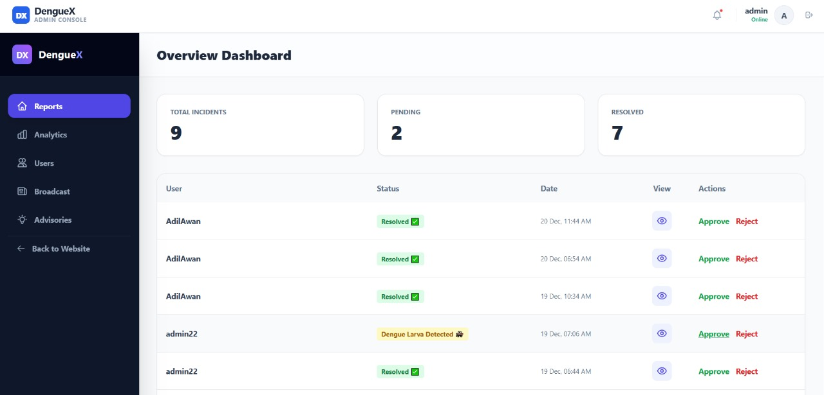
Figure 4.7: Administrative control panel for dengue management

4.5 Data Flow Design
DengueX manages data through a specific process:
1. A user sends a request through the chatbot, a report, or an image.
2. The backend checks if the request is valid.
3. AI tools analyse the input.
4. The system saves or gets results from the database.
5. The output is then shown to the user.
This method cuts down on repetition and helps make sure data is handled correctly.

4.6 Database Design Overview
The system database architecture is structured to encourage modular data storage practices. Several key entities form the base of this structure:
- Users: This entity stores detailed information about individual users of the system. It includes attributes such as usernames, contact details, roles, permissions, and access history. User data is vital for authentication, authorization, and personalization of the system experience. The design ensures that user information can be updated and managed efficiently.
- Reports: The system stores various generated reports. These reports may present summaries, detailed analyses, or visualizations of the data within the system. Attributes associated with the Reports entity include the type of report, creation date, author, relevant data filters, and accessibility permissions. The reports are essential for decision-making, performance evaluation, and understanding patterns within the available data. Stored reports are easily retrievable.
- Dengue Statistics: This crucial entity holds the recorded statistics related to dengue fever cases. Data points stored here cover geographical location, patient demographics, infection rates, serotypes, and related health indicators. The data is important for epidemiological studies, resource allocation during outbreaks, and predictive modelling. Privacy measures are implemented to safeguard patient confidentiality. Information is updated as new data is gathered.
- AI Logs: This entity records the activities and outputs of artificial intelligence algorithms running within the system. These logs include details about model training, predictions, error rates, and any interventions suggested by the AI. These logs provide a record of AI's contribution.
- Admin Actions: All actions taken by system administrators are logged within this entity. This includes user management activities such as account creation, permission modifications, data backups, system updates, and security configuration changes. Detailed logging of administrative actions is required for auditing, accountability, and system security. Actions are tagged with timestamps, user IDs, and specific details about the changes that were made.
The design stresses relationships between these entities to assure data consistency and traceability across the system.

4.7 User Interface Design
The user interface is designed with a focus on simplicity and clarity, prioritizing ease of use for all users. Several design principles guide its structure:
1. A minimalistic layout avoids unnecessary clutter, presenting information in a clean and digestible way. This approach helps users focus on essential elements without feeling overwhelmed.
2. Intuitive navigation ensures users can easily find what they need. The site's structure and labeling are logical and predictable, reducing the learning curve.
3. A clear visual hierarchy guides the user's eye, establishing the importance of different elements on the page. This is achieved through careful use of typography, spacing, and colour.

4. Mobile-responsive design allows the interface to adapt seamlessly to various screen sizes and devices, ensuring a consistent experience across desktops, tablets, and smartphones.
The interface includes the following screens:
- Login/Register page: This screen allows new users to create accounts and existing users to access their profiles securely. It follows security protocols and easy recover options.
- Dashboard: A central hub providing an overview of key information and quick access to frequently used features. Information is displayed and can be customized of priorities.
- Chatbot: An interface for interacting with an automated assistant that can answer common questions, offer and provide support, and manage tasks.
- Reporting form: A straightforward form that allows users to submit feedback, report issues, or request assistance.
Admin panel: A secure area where authorized personnel can manage user accounts, configure system settings, and monitor overall performance. It is used for granting, deleting, and modifying accounts.

4.8 Scalability and Future Design Support
The system's structure is created to allow for later improvements. These improvements include:
- Connecting the system to mobile apps. This would allow users to access the system's features on their phones or tablets, making it more accessible.
- Creating a way to predict outbreaks in real time. This would allow health officials to respond quickly and efficiently to potential health crises.
- Connecting the system with government health APIs. This would allow the system to share data with and get data from government health agencies, improving coordination and data sharing.
Because of its modular design, these features can be added without needing to make big changes to the system's structure. This modularity makes the system more flexible and adaptable to future needs. The benefit of multi-language chatbot support is that it can broaden the user base and accommodate those who are not fluent in the primary language of the system. The mobile application integration will extend the system's as it makes it more available and helpful for on-the-go access to data and tools. The system is prepared to adjust to future technological changes and user expectations thanks to its ability to accommodate these changes. This modular design makes it more flexible and guarantees that it will continue to be helpful and pertinent for many years to come.

